In this document we will discuss

Parts of my dream setup with pictures,specifications and shot info about each part

1.case

There is no pc build without a case so i picked the **NZXT H6 Flow | White**NZXT H6 Flow | White


Why did I pick it ?

Because its cheap 130$ and

it has a good cooling system

And this is a comparison between the nzxt h6 flow and another case

| **Cooler Master NCORE 100 Air** | Nzxt h6 flow |
| --- | --- |
| * **Newer Product**, it was released around **15 months** later. | * **+1** internal 2.5" bays.and 3.5" bays. |
|  | * Additional VGA length allowance (**+9.00mm**). |
|  | * **+5** Expansion slots. |
|  | * Supports formats: **ATX, Micro ATX**. |

2.cpu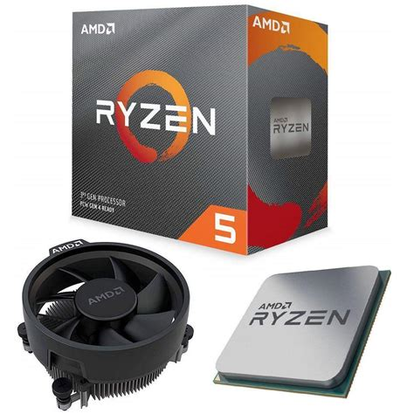

I chose the [AMD Ryzen 5 3600, 6-Cores and 12-Thread Unlocked Desktop Processor with Wraith Stealth Cooler](https://pcbuilder.net/component-details/processor/amd-ryzen-5-3600-100-100000031box/)

As intel sucks i chose an amd ryzen 5 5600 with a [Cooler Master i70C ARGB](https://pcbuilder.net/component-details/cpu-cooler/cooler-master-rr-i7c7-18pa-r1/)

Cooler for a total of 97$ which is a powerful cpu and very affordable,too

3.GPU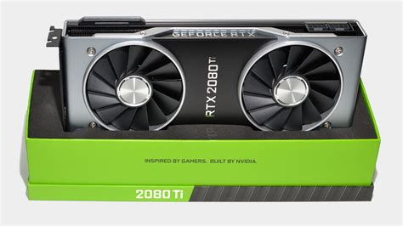

I picked the nvidia RTX 2080-TI for 979$

4. Motherboard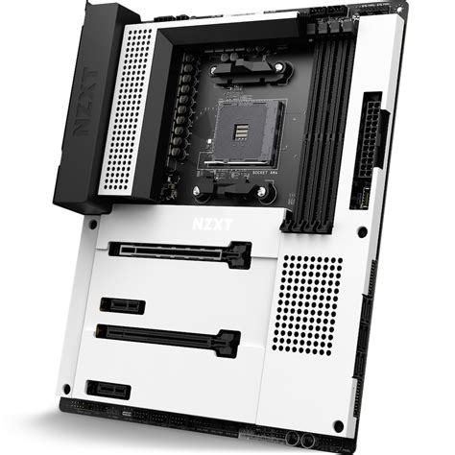

I pitched an nzxt mother board nztx n7 b550 white for 120$

5.ram

I picked the 82$ [Corsair Vengeance LPX 16GB (2 X 8GB) DDR4 4000](https://pcbuilder.net/component-details/ram/corsair-vengeance-lpx-cmk16gx4m2z4000c18/) amd-optimized ram 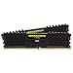

6.hard drive

Of course we cant use a computer especially if your a programmer without a ton of storage so i picked the 1TB [Samsung EVO 970](https://pcbuilder.net/component-details/storage/samsung-970-evo-mz-v7e1t0bw/) 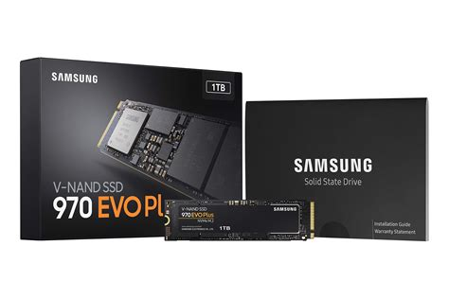

And i don't need any network card because the motherboard i picked has wifi 6 capabilities and bluetooth

Number 7 case cooler

I chose the [ARCTIC P12 PWM PST - 120 mm Case Fan with PWM Sharing Technology (PST), Pressure-optimised, Quiet Motor](https://pcbuilder.net/component-details/case-cooler/arctic-p12-pst-acfan00132a/) white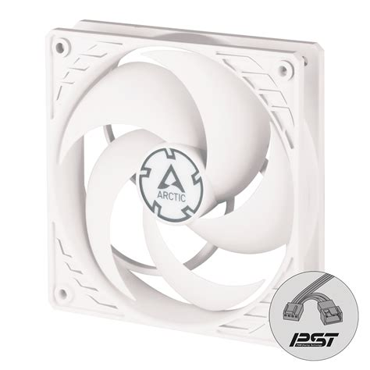

Number 8 Power supply

[Thermaltake Toughpower GX3 850W 80Plus](https://pcbuilder.net/component-details/power-supply/thermaltake-ps-tpd-0850nnfagu-3/) for 100 bucks

Up next is the display

So a programmer needs at least 17 inches of real estate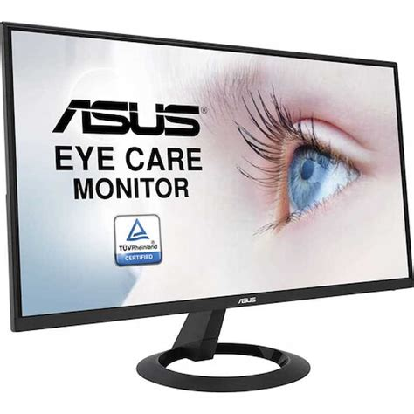

So i got myself a [ASUS VA24DQLB 23.8” Monitor, 1080P Full HD](https://pcbuilder.net/component-details/monitor/asus-va24dqlb/)

Up next are peripherals

Fo the keyboard i got [Logitech MX Keys Mini](https://pcbuilder.net/component-details/keyboard/logitech-920-010473/)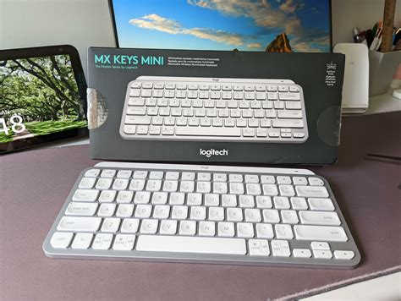

For my mouse i got the [Logitech MX Master 3S](https://pcbuilder.net/component-details/mouse/logitech-910-006558/)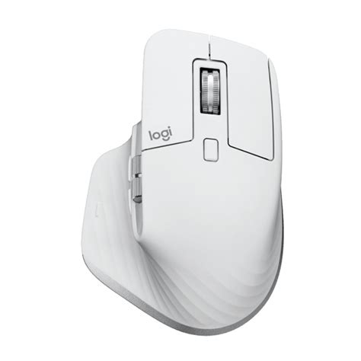

I chose not to get speakers i will get headphones instead 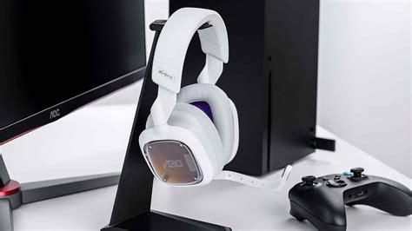

I will pick the [Logitech G Astro A30](https://pcbuilder.net/component-details/headphone/astro-gaming-939-001992/)

For 132 bucks

I got The [Adesso Cybertrack H6 4K Ultra HD USB Webcam with Built-in Dual Microphone & Privacy Shutter Cover](https://pcbuilder.net/component-details/webcam/adesso-cybertrack-h6/)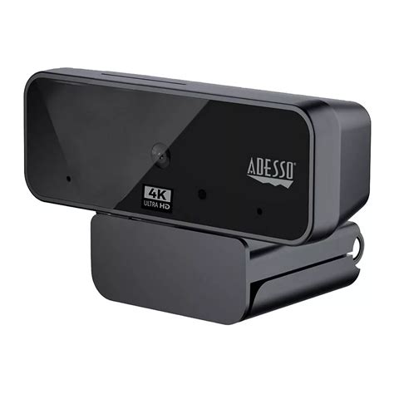

For the os i will install [Ubuntu 25.04](https://ubuntu.com/download/desktop)

## And the grand total is 🥁 2186$